VIII Lecture: İntroduction to basic microbiology. Causative agents of pus-inflammatory diseases. Pathogenic cocci (genus Staphylococcus, Streptococcus, Neisseria). Opportunistic bacteria (genus Pseudomonas, Proteus, Klebsiella).

The purpose of the lecture: Introduction to specific microbiology, clinically important bacteria: pathogenic and opportunistic Gram-positive cocci(species of Staphylococcus,Streptococcus), Gram-negative cocci (species Neisseria), pathogenic and opportunistic Gram-negative rodents (Pseudomonas, Acinetobacter, Proteus, Klebsiella species, their morpho-biological characteristics,, microbiological diagnostics, specific treatment and provide information on prevention.

Lecture plan:
1. The concept of specific microbiology
2. Pathogenic and opportunistic cocci:
- Gram-positive cocci (staphylococci, streptococci, pneumococci, enterococci), Gram-negative cocci (meningococci, gonococci, conditionally pathogenic neisseria). Classification, morpho-biological features, diseases caused by these bacteria, microbiological diagnosis, specific principles of treatment and prevention
3. Conditionally pathogenic bacteria:
- Characteristics, role of Pseudomonas in human pathology
- Conditionally pathogenic bacteria from the family Enterobacteriaceae - Klebsiellae and Proteus, characteristics, role in human pathology
-Acinetobacter species, their morpho-biological characteristics, microbiological diagnosis, specific treatment and prevention.

Lecture equipment: Computer, projector, electronic slides
Literature: p.1

Medical microbiology - studies the characteristics of microorganisms that cause disease in humans and the pathological processes that occur in the organism during these diseases. Development of laboratory diagnosis, specific prevention and treatment methods of diseases caused by microorganisms are the main tasks of medical microbiology.
Special microbiology - studies the characteristics of various microorganisms and is divided into the following departments depending on this: - bacteriology (science of bacteria) - virology (science of viruses) - - mycology (science of fungi) - - protozoology (the science that studies protozoas)
Pathogenic cocci
Gram-positive cocci:
• Aerobic genus: Micrococcus, Planococcus və Deinococcus
• Facultative anaerobic genus: Staphylococcus, Stomatococcus, Streptococcus, Leuconostoc, Pediococcus, Aerococcus and Gemella
• Anaerobic genus: Peptococcus, Peptostreptococcus, Ruminococcus, Coprococcus, Sarcina
There are two medically important genera of gram-positive cocci: Staphylococcus and Streptococcus. Two of the most important human pathogens, Staphylococcus aureus and Streptococcus pyogenes, are described in this chapter. Staphylococci and streptococci are nonmotile and do not form spores.Both staphylococci and streptococci are gram-positive cocci, but they are distinguished by two main criteria: (1) Microscopically, staphylococci appear in grapelike clusters, whereas streptococci are in chains. (2) Biochemically, staphylococci produce catalase (i.e., they degrade hydrogen peroxide), whereas streptococci do not.
Staphylococcaceae family (new taxonomy)
• Domain: Bacteria
• Kingdom: Bacillota
• Class: Bacilli
• Order: Bacillates
• Family: Staphylococcaceae
• Genus: Staphylococcus
• Species: It consists of about 40 species (S.hominis, S.albus, S.haemolyticus, S.simulans, S.sciuri, etc.). But medically important species are S.aureus, S.epidermidis, S.saprophyticus.

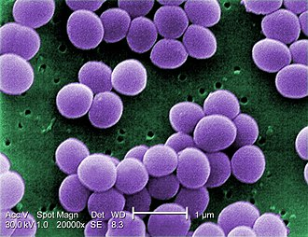
Staphylococcus aureus
Staphylococcus aureus causes abscesses , various pyogenic infections (e.g., endocarditis, septic arthritis, and osteomyelitis), food poisoning, scalded skin syndrome, and toxic shock syndrome. It is one of the most common causes of hospital-acquired pneumonia, septicemia, and surgical-wound infections. It is an important cause of skin and soft tissue infections, such as folliculitis, cellulitis, and impetigo . It is the most common cause of bacterial conjunctivitis.
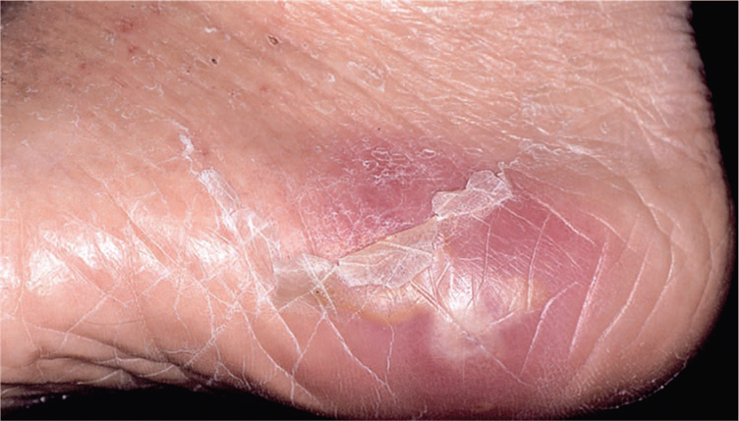
Abscess on foot.
Staphylococcus epidermidis causes prosthetic valve endocarditis and prosthetic joint infections. It is the most common cause of central nervous system shunt infections and an important cause of sepsis in newborns. Staphylococcus saprophyticus causes urinary tract infections, especially cystitis. Kawasaki syndrome is a disease of unknown etiology that may be caused by certain strains of S. aureus.

Important properties
Staphylococci are spherical gram-positive cocci arranged in irregular grapelike clusters . All staphylococci produce catalase, whereas no streptococci do (catalase degrades H2O2 into O2 and H2O). Catalase is an important virulence factor. Bacteria that make catalase can survive the killing effect of H2O2 within neutrophils. Three species of staphylococci are important human pathogens: S. aureus, S. epidermidis, and S. saprophyticus.Of these three, S. aureus is by far the most common and causes the most serious infections. Staphylococcus aureus is distinguished from the others primarily by coagulase production . Coagulase is an enzyme that causes plasma to clot by activating prothrombin to form thrombin. Thrombin then catalyzes the activation of fibrinogen to form the fibrin clot. Staphylococcus epidermidis and S. saprophyticus are often referred to as coagulase-negative staphylococci. Staphylococcus aureus produces a carotenoid pigment called staphyloxanthin, which imparts a golden color to its colonies. This pigment enhances the pathogenicity of the organism by inactivating the microbicidal effect of superoxides and other reactive oxygen species within neutrophils. Staphylococcus epidermidis does not synthesize this pigment and produces white colonies. The virulence of S. epidermidis is significantly less than that of S. aureus.Two other characteristics further distinguish these species, namely, S. aureus usually ferments mannitol and hemolyzes red blood cells, whereas S. epidermidis and S. saprophyticus do not. Hemolysis of red cells by hemolysins produced by S. aureus is the source of iron required for growth of the organism. The iron in hemoglobin is recovered by the bacteria and utilized in the synthesis of cytochrome enzymes used to produce energy.
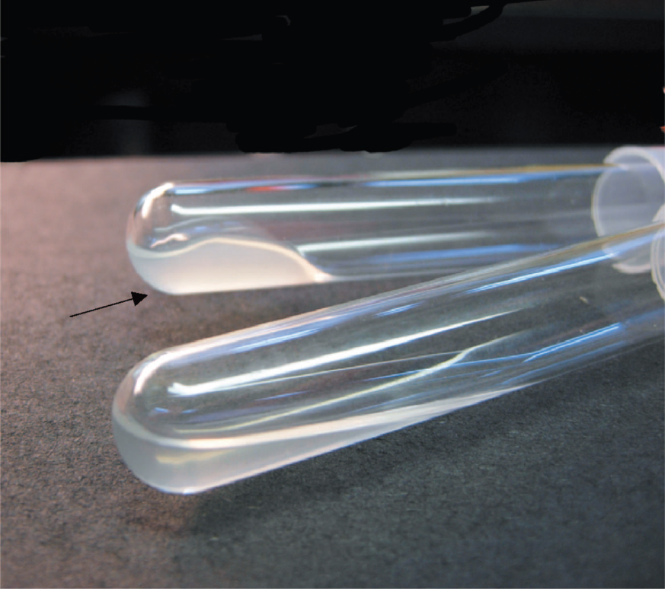
Coagulase test—Upper tube inoculated with Staphylococcus aureus; lower tube inoculated with Staphylococcus epidermidis. Arrow points to clotted plasma formed by coagulase produced by S. aureus.
More than 90% of S. aureus strains contain plasmids that encode a-lactamase, the enzyme that degrades many, but not all, penicillins. Some strains of S. aureus are resistant to the β-lactamase–resistant penicillins, such as methicillin and nafcillin, by virtue of changes in the penicillin-binding proteins (PBP) in their cell membrane.Genes on the bacterial chromosome called mecA genes encode these altered PBPs.
S. aureus has several important cell wall components and antigens:
(1) Protein A is the major protein in the cell wall. It is an important virulence factor because it binds to the Fc portion of IgG at the complement-binding site, thereby preventing the activation of complement. As a consequence, no C3b is produced, and the opsonization and phagocytosis of the organisms are greatly reduced. Protein A is used in certain tests in the clinical laboratory because it binds to IgG and forms a “coagglutinate” with antigen–antibody complexes. The coagulase-negative staphylococci do not produce protein A.

(2) Teichoic acids are polymers of ribitol phosphate. They mediate adherence of the staphylococci to mucosal cells. Lipoteichoic acids play a role in the induction of septic shock by inducing cytokines such as interleukin-1 (IL-1) and tumor necrosis factor (TNF) from macrophages.
(3) Polysaccharide capsule is also an important virulence factor. There are 11 serotypes based on the antigenicity of the capsular polysaccharide, but types 5 and 8 cause 85% of infections. Some strains of S. aureus are coated with a small amount of polysaccharide capsule, called a microcapsule. The capsule is poorly immunogenic, which has made producing an effective vaccine difficult.
(4) Surface receptors for specific staphylococcal bacteriophages permit the “phage typing” of strains for epidemiologic purposes. Teichoic acids make up part of these receptors.
(5) The peptidoglycan of S. aureus has endotoxin-like properties (i.e., it can stimulate macrophages to produce cytokines and can activate the complement and coagulation cascades). This explains the ability of S. aureus to cause the clinical findings of septic shock yet not possess endotoxin.
Pathogenesis
Staphylococcus aureus
Staphylococcus aureus causes disease both by producing toxins and by inducing pyogenic inflammation. The typical lesion of S. aureus infection is an abscess. Abscesses undergo central necrosis and usually drain to the outside (e.g., furuncles and boils), but organisms may disseminate via the bloodstream as well. Foreign bodies, such as sutures and intravenous catheters, are important predisposing factors to infection by S. aureus. Several important toxins and enzymes are produced by S. aureus. The three clinically important exotoxins are enterotoxin, toxic shock syndrome toxin, and exfoliatin.
(1) Enterotoxin causes food poisoning characterized by prominent vomiting and watery, nonbloody diarrhea. It acts as a superantigen within the gastrointestinal tract to stimulate the release of large amounts of IL-1 and IL-2 from macrophages and helper T cells, respectively. The prominent vomiting appears to be caused by cytokines released from the lymphoid cells, which stimulate the enteric nervous system to activate the vomiting center in the brain. Enterotoxin is fairly heat-resistant and is therefore usually not inactivated by brief cooking. It is resistant to stomach acid and to enzymes in the stomach and jejunum. There are six immunologic types of enterotoxin, types A–F.
(2) Toxic shock syndrome toxin (TSST) causes toxic shock, especially in tampon-using menstruating women or in individuals with wound infections. Toxic shock also occurs in patients with nasal packing used to stop bleeding from the nose. TSST is produced locally by S. aureus in the vagina, nose, or other infected site. The toxin enters the bloodstream, causing a toxemia. Blood cultures typically do not grow S. aureus. TSST is a superantigen and causes toxic shock by stimulating the release of large amounts of IL-1, IL-2, and TNF . Approximately 5% to 25% of isolates of S. aureus carry the gene for TSST. Toxic shock occurs in people who do not have antibody against TSST.
(3) Exfoliatin causes “scalded skin” syndrome in young children. It is “epidermolytic” and acts as a protease that cleaves desmoglein in desmosomes, leading to the separation of the epidermis at the granular cell layer.
(4) Several exotoxins can kill leukocytes (leukocidins) and cause necrosis of tissues in vivo. Of these, the two most important are alpha toxin and P-V leukocidin. Alpha toxin causes marked necrosis of the skin and hemolysis. The cytotoxic effect of alpha toxin is attributed to the formation of holes in the cell membrane and the consequent loss of low-molecular-weight substances from the damaged cell.
(5) The enzymes include coagulase, fibrinolysin, hyaluronidase,proteases, nucleases, and lipases. Coagulase, by clotting plasma, serves to wall off the infected site, thereby retarding the migration of neutrophils into the site. Staphylokinase is a fibrinolysin that can lyse thrombi.
Staphylococcus epidermidis & Staphylococcus saprophyticus
Unlike S. aureus, these two coagulase-negative staphylococci do not produce exotoxins. Thus, they do not cause food poisoning or toxic shock syndrome. They do, however, cause pyogenic infections. For example, S. epidermidis is a prominent cause of pyogenic infections on prosthetic implants such as heart valves and hip joints, and S. saprophyticus causes urinary tract infections, especially cystisis.

Clinical findings
The important clinical manifestations caused by S. aureus can be divided into two groups: pyogenic (pus-producing) and toxin-mediated . Staphylococcus aureus is a major cause of skin, soft tissue, bone, joint, lung, heart, and kidney infections. Pyogenic diseases are the first group described, and toxin-mediated diseases are the second group.

Staphylococcus aureus: Pyogenic Diseases
(1) Skin and soft tissue infections are very common.These include abscess , impetigo , furuncles, carbuncles , paronychia,cellulitis, folliculitis , hidradenitis suppurativa, conjunctivitis, eyelid infections (blepharitis and hordeolum), and postpartum breast infections (mastitis).Lymphangitis can occur, especially on the forearm associated with an infection on the hand.
2) Septicemia (sepsis) can originate from any localized lesion, especially wound infection, or as a result of intravenous drug abuse. Sepsis caused by S. aureus has clinical features similar to those of sepsis caused by certain gram-negative bacteria, such as Neisseria meningitidis .
(3) Endocarditis may occur on normal or prosthetic heart valves, especially right-sided endocarditis (tricuspid valve) in intravenous drug users. (Prosthetic valve endocarditis is often caused by S. epidermidis.)
(4) Osteomyelitis and septic arthritis may arise either by hematogenous spread from a distant infected focus or be introduced locally at a wound site. Staphylococcus aureus is a very common cause of these diseases, especially in children.
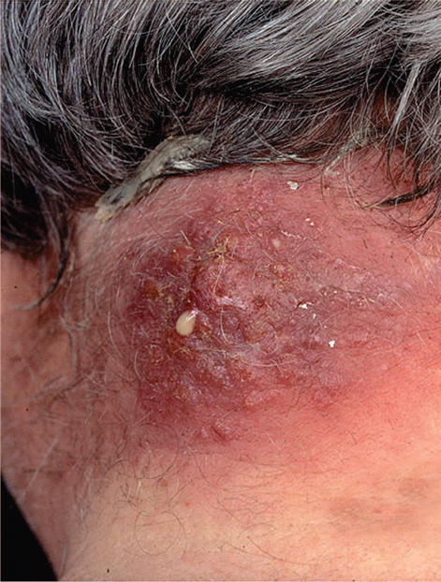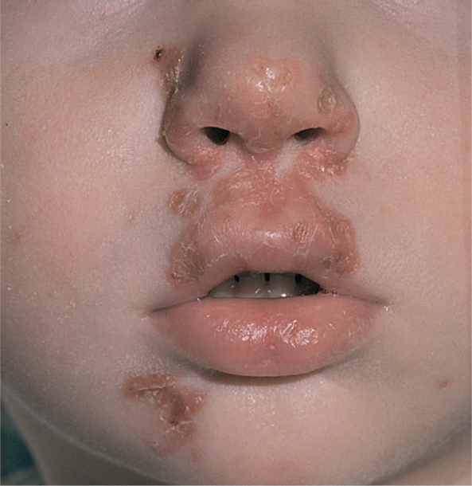

(5) Staphylococcus aureus is the most common cause of postsurgical wound infections which are an important cause of morbidity and mortality in hospitals. For example, S. aureus and S. epidermidis are the most common causes of infections at the site where cardiac pacemakers are installed.
(6) Pneumonia can occur in postoperative patients or following viral respiratory infection, especially influenza. Staphylococcal pneumonia often leads to empyema or lung abscess. In many hospitals, it is the most common cause of nosocomial pneumonia in general and especially of ventilatorassociated
pneumonia in intensive care units. CA-MRSA causes a severe necrotizing pneumonia.
(7) Conjunctivitis typically presents with unilateral burning eye pain, hyperemia of the conjunctiva, and a purulent discharge. The organism is transmitted to the eye by contaminated fingers. Staphylococcus aureus is the most common cause overall, but S. pneumoniae and Haemophilus influenzae are more common in children. Gonococcal and nongonococcal (caused by Chlamydia trachomatis) conjunctivitis is acquired by infants during passage through the birth canal.
(8) Abscesses can occur in any organ when S. aureus circulates in the bloodstream (bacteremia). These abscesses are often called “metastatic abscesses” because they occur by the spread of bacteria from the original site of infection,often in the skin.
Staphylococcus aureus: Toxin-Mediated Diseases
(1) Food poisoning (gastroenteritis) is caused by ingestion of enterotoxin, which is preformed in foods and hence has a short incubation period (1–8 hours). In staphylococcal food poisoning, vomiting is typically more prominent than diarrhea.
(2) Toxic shock syndrome is characterized by fever; hypotension; a diffuse, macular, sunburn-like rash that goes on to desquamate; and involvement of three or more of the following organs: liver, kidney, gastrointestinal tract, central nervous system, muscle, or blood.
(3) Scalded-skin syndrome is characterized by fever, large bullae, and an erythematous macular rash. Large areas of skin slough, serous fluid exudes, and electrolyte imbalance can occur. Hair and nails can be lost. Recovery usually occurs within 7–10 days. This syndrome occurs most often in young children.

Laboratory diagnosis
Smears from staphylococcal lesions reveal gram-positive cocci in grapelike clusters . Cultures of
S. aureus typically yield golden-yellow colonies that are usually β-hemolytic. Staphylococcus aureus is coagulasepositive. Mannitol-salt agar is a commonly used screening device for S. aureus. Staphylococcus aureus ferments mannitol, which lowers the pH causing the agar to turn yellow whereas S. epidermidis does not ferment mannitol and the agar remains pink. Cultures of coagulase-negative staphylococci typically yield white colonies that are nonhemolytic. The two coagulasenegative staphylococci are distinguished by their reaction to the antibiotic novobiocin: S. epidermidis is sensitive, whereas S. saprophyticus is resistant. There are no serologic or skin tests used for the diagnosis of any acute staphylococcal infection. In toxic shock syndrome, isolation of S. aureus is not required to make a diagnosis as long as the clinical criteria are met. Laboratory findings that support a diagnosis of toxic shock syndrome include the isolation of a TSSTproducing strain of S. aureus and development of antibodies to the toxin during convalescence, although the latter is not useful for diagnosis during the acute disease. For epidemiologic purposes, S. aureus can be subdivided into subgroups based on the susceptibility of the clinical isolate to lysis by a variety of bacteriophages. A person carrying S. aureus of the same phage group as that which caused the outbreak may be the source of the infections.
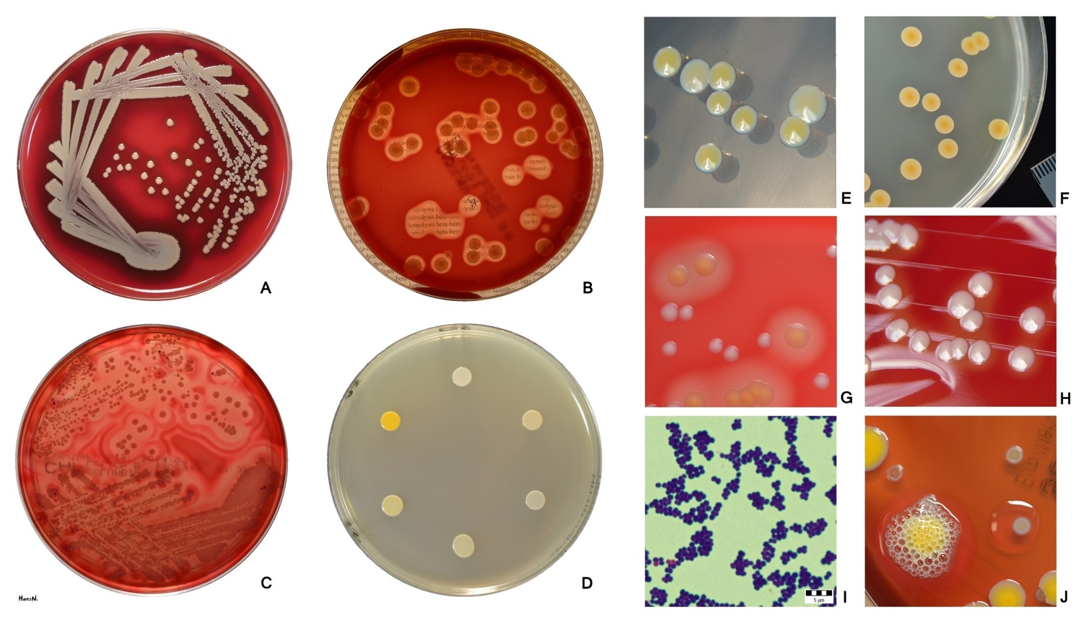

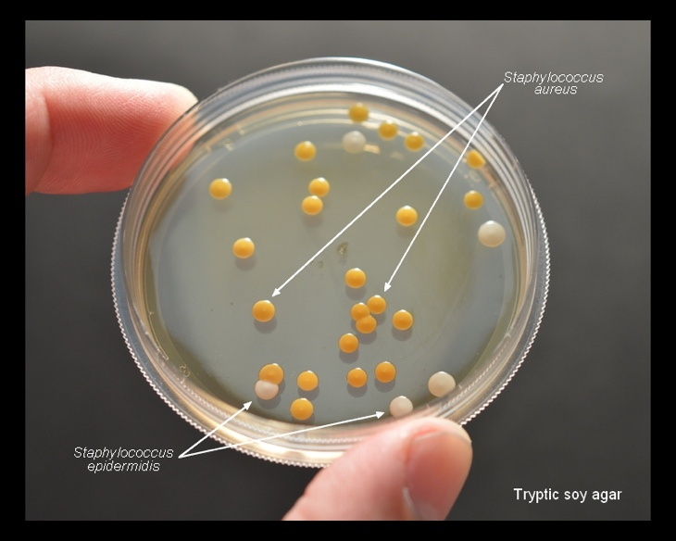
There is no vaccine against staphylococci. Cleanliness, frequent handwashing, and aseptic management of lesions help to control spread of S. aureus. Persistent colonization of the nose by S. aureus can be reduced by intranasal mupirocin or by oral antibiotics, such as ciprofloxacin or trimethoprim-sulfamethoxazole, but is difficult to eliminate completely. Shedders may have to be removed from high-risk areas (e.g., operating rooms and newborn nurseries). Cefazolin is often used perioperatively to prevent staphylococcal surgical-wound infections.

Streptococcus
There is no vaccine against staphylococci. Cleanliness, frequent handwashing, and aseptic management of lesions help to control spread of S. aureus. Persistent colonization of the nose by S. aureus can be reduced by intranasal mupirocin or by oral antibiotics, such as ciprofloxacin or trimethoprim-sulfamethoxazole, but is difficult to eliminate completely. Shedders may have to be removed from high-risk areas (e.g., operating rooms and newborn nurseries). Cefazolin is often used perioperatively to prevent staphylococcal surgical-wound infections.
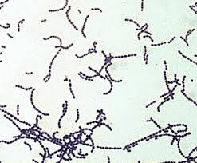
Important properties
Streptococci are spherical gram-positive cocci arranged in chains or pairs . All streptococci are catalasenegative, whereas staphylococci are catalase-positive.One of the most important characteristics for identification of streptococci is the type of hemolysis .
(1) alfa-Hemolytic streptococci form a green zone around their colonies as a result of incomplete lysis of red blood cells in the agar. The green color is formed when hydrogen peroxide produced by the bacteria oxidizes hemoglobin (red color) to biliverdin (green color).
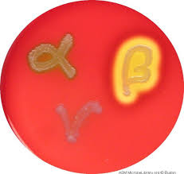

(2) a-Hemolytic streptococci form a clear zone around their colonies because complete lysis of the red cells occurs. β-Hemolysis is due to the production of enzymes (hemolysins) called streptolysin O and streptolysin S . (3) Some streptococci are nonhemolytic (γ-hemolysis). There are two important antigens of β-hemolytic streptococci:
(1) C carbohydrate determines the group of β-hemolytic streptococci. It is located in the cell wall, and its specificity is determined by an amino sugar. For example, Group A β-hemolytic streptococci (S. pyogenes) is distinguished from Group B β-hemolytic streptococci (S. agalactiae) because it has a different C carbohydrate. (2) M protein is the most important virulence factor of S. pyogenes. It protrudes from the outer surface of the cell and blocks phagocytosis (i.e., it is antiphagocytic). It inactivates C3b, a component of complement that opsonizes the bacteria prior to phagocytosis . Strains of S. pyogenes that do not produce M protein are nonpathogenic. M protein also determines the type of group A β-hemolytic streptococci. There are approximately 100 serotypes based on the M protein, which explains why multiple infections with S. pyogenes can occur. Antibody to M protein provides type-specific immunity. Strains of S. pyogenes that produce certain M protein types are rheumatogenic (i.e., cause primarily rheumatic fever), whereas strains of S. pyogenes that produce other M protein types are nephritogenic (i.e., cause primarily acute glomerulonephritis). Although M protein is the main antiphagocytic component of S. pyogenes, the organism also has a polysaccharide capsule that plays a role in retarding phagocytosis. 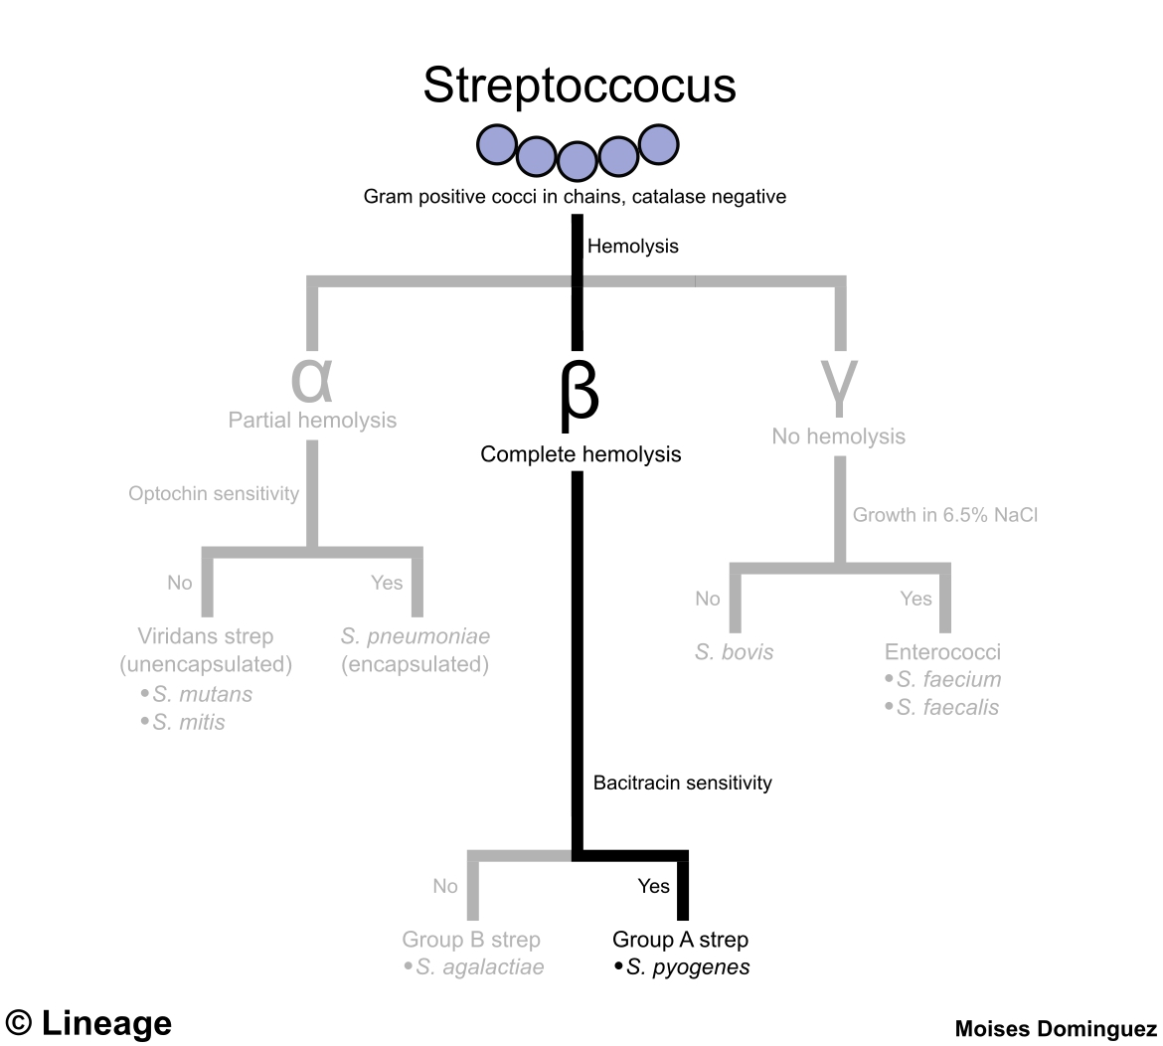

Classification of Streptococci

a-Hemolytic Streptococci
These are arranged into groups A–U (known as Lancefield groups) on the basis of antigenic differences in C carbohydrate.In the clinical laboratory, the group is determined by precipitin tests with specific antisera or by immunofluorescence.
Group A streptococci (S. pyogenes) are one of the most important human pathogens. They are the most frequent bacterial cause of pharyngitis and a very common cause of skin infections. They adhere to pharyngeal epithelium via pili composed of lipoteichoic acid and M protein. Many strains have a hyaluronic acid capsule that is antiphagocytic.The growth of S. pyogenes on agar plates in the laboratory is inhibited by the antibiotic bacitracin, an important diagnostic criterion. Group B streptococci (S. agalactiae) colonize the genital tract of some women and can cause neonatal meningitis and sepsis. They are usually bacitracin-resistant. They hydrolyze (break down) hippurate, an important diagnostic criterion. Group D streptococci include enterococci (e.g., E. faecalis and Enterococcus faecium) and nonenterococci (e.g.,S. bovis). Enterococci are members of the normal flora of the colon and are noted for their ability to cause urinary,biliary, and cardiovascular infections. They are very hardy organisms; they can grow in hypertonic (6.5%) saline or in bile and are not killed by penicillin G. As a result, a synergistic combination of penicillin and an aminoglycoside(e.g., gentamicin) is required to kill enterococci. Vancomycin can also be used, but vancomycin-resistant enterococci(VRE) have emerged and become an important and much feared cause of life-threatening nosocomial infections. More strains of E. faecium are vancomycin-resistant than are strains of E. faecalis. Nonenterococcal group D streptococci, such as S. bovis, can cause similar infections but are much less hardy organisms (e.g., they are inhibited by 6.5% NaCl and killed by penicillin G). Note that the hemolytic reaction of group D streptococci is variable: most are α-hemolytic, but some are β-hemolytic, and others are nonhemolytic.
Groups C, E, F, G, H, and K–U streptococci infrequently cause human disease.
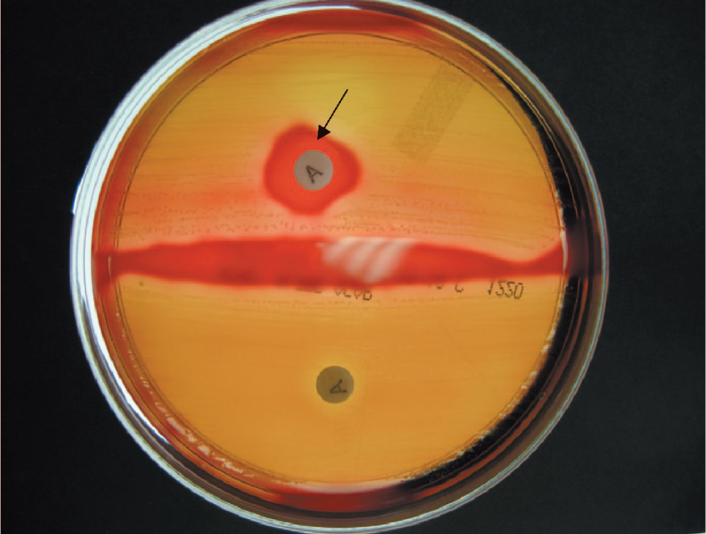
Bacitracin test—Arrow points to zone of inhibition of growth of group A streptococci (Streptococcus pyogenes) caused by bacitracin that has diffused from the disk labeled A. Upper half of blood agar plate shows β-hemolysis caused by group A streptococci, except in the region around the bacitracin disk. Lower half of blood agar plate shows β-hemolysis caused by group B streptococci

Non–a-Hemolytic Streptococci
Some streptococci produce no hemolysis; others produce α-hemolysis. The principal α-hemolytic organisms are S. pneumoniae (pneumococci) and the viridans group of streptococci (e.g., Streptococcus mitis, Streptococcus sanguinis, and Streptococcus mutans). Pneumococci and viridans streptococci are distinguished in the clinical laboratory by two main criteria: (1) the growth of pneumococci is inhibited by optochin, whereas the growth of viridans streptococci is not inhibited; and (2) colonies of pneumococci dissolve when exposed to bile (bile-soluble), whereas colonies of viridans streptococci do not dissolve. Viridans streptococci are part of the normal flora of the human pharynx and intermittently reach the bloodstream to cause infective endocarditis. Streptococcus mutans synthesizes polysaccharides (dextrans) that are found in dental plaque and lead to dental caries. Streptococcus intermedius and Streptococcus anginosus (also known as the S. anginosusmilleri group) are usually α-hemolytic or nonhemolytic, but some isolates are β-hemolytic. They are found primarily in the mouth and colon.

Pathogenesis
Group A streptococci (S. pyogenes) cause disease by three mechanisms: (1) pyogenic inflammation, which is induced locally at the site of the organisms in tissue; (2) exotoxin production, which can cause widespread systemic symptoms in areas of the body where there are no organisms; and (3) immunologic, which occurs when antibody against a component of the organism cross-reacts with normal tissue or forms immune complexes that damage normal tissue. The immunologic reactions cause inflammation (e.g., the inflamed joints of rheumatic fever), but there are no organisms in the lesions. The M protein of S. pyogenes is its most important antiphagocytic factor, but its capsule, composed of hyaluronic acid, is also antiphagocytic. Antibodies are not formed against the capsule because hyaluronic acid is a normalcomponent of the body and humans are tolerant to it. Group A streptococci produce three important inflammation-related enzymes:(1) Hyaluronidase degrades hyaluronic acid, which is the ground substance of subcutaneous tissue. Hyaluronidase is known as spreading factor because it facilitates the rapid spread of S. pyogenes in skin infections (cellulitis). (2) Streptokinase (fibrinolysin) activates plasminogen to form plasmin, which dissolves fibrin in clots, thrombi, and emboli. It can be used to lyse thrombi in the coronary arteries of heart attack patients. (3) DNase (streptodornase) degrades DNA in exudates or necrotic tissue. Antibody to DNase B develops during pyoderma; this can be used for diagnostic purposes. Streptokinase–streptodornase mixtures applied as a skin test give a positive reaction in most adults, indicating normal cell-mediated immunity.
In addition, group A streptococci produce five important toxins and hemolysins: erythrogenic toxin, streptolysin O, streptolysin S, pyrogenic exotoxin A, exotoxin B.
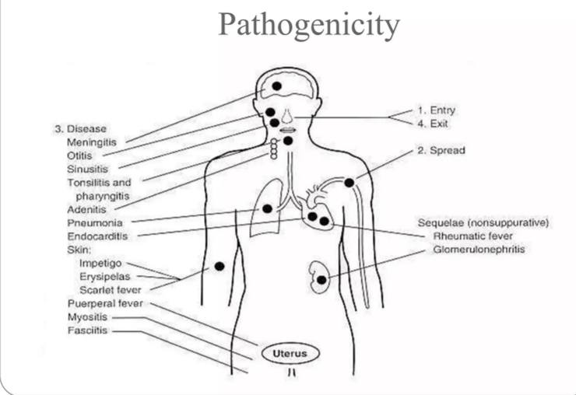

Clinical findings
Streptococcus pyogenes causes three types of diseases: (1) pyogenic diseases such as pharyngitis and cellulitis, (2)toxigenic diseases such as scarlet fever and toxic shock syndrome, and (3) immunologic diseases such as rheumatic fever and acute glomerulonephritis (AGN). (See next section on poststreptococcal diseases.) Streptococcus pyogenes (group A streptococcus) is the most common bacterial cause of pharyngitis (sore throat). Streptococcal pharyngitis (strep throat) is characterized by throat pain and fever. On examination, an inflamed throat and tonsils, often with a yellowish exudate, are found, accompanied by tender cervical lymph nodes. If untreated, spontaneous recovery often occurs in 10 days, but rheumatic fever may occur (see next section on poststreptococcal diseases). Untreated pharyngitis may extend to the middle ear (otitis media), the sinuses (sinusitis), the mastoids (mastoiditis), or the meninges (meningitis). Continuing inability to swallow may indicate a peritonsillar or retropharyngeal abscess.
Group A streptococci cause skin and soft tissue infections, such as cellulitis, erysipelas ,necrotizing fasciitis (streptococcal gangrene), and impetigo. Impetigo, a form of pyoderma, is a superficial skin infection characterized by “honeycolored” crusted lesions. Lymphangitis can occur, especially on the forearm associated with an infection on the hand. Group B streptococci cause neonatal sepsis and meningitis. The main predisposing factor is prolonged (longer than 18 hours) rupture of the membranes in women who are colonized with the organism. Children born prior to 37 weeks’ gestation have a greatly increased risk of disease. Also, children whose mothers lack antibody to group B streptococci and who consequently are born without transplacentally acquired IgG have a high rate of neonatal sepsis caused by this organism. Group B streptococci are an important cause of neonatal pneumonia as well.
Viridans streptococci (e.g., S. mutans, S. sanguinis, S.salivarius, and S. mitis) are the most common cause of infective endocarditis. They enter the bloodstream (bacteremia) from the oropharynx, typically after dental surgery. Signs of endocarditis are fever, heart murmur, anemia, and embolic events such as splinter hemorrhages, subconjunctival petechial hemorrhages, and Janeway lesions.

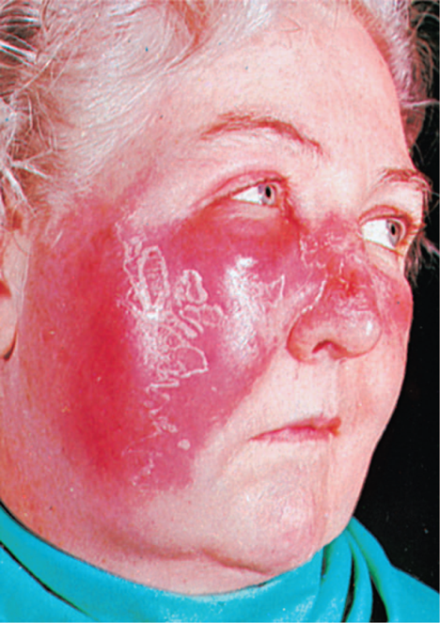
Erysipelas. Note well-demarcated border of the inflamed area. Streptococcus pyogenes is the most common cause of erysipelas.
Laboratory Diagnosis
Gram-stained smears are useless in streptococcal pharyngitis because viridans streptococci are members of the normal flora and cannot be visually distinguished from the pathogenic S. pyogenes. However, stained smears from skin lesions or wounds that reveal streptococci are diagnostic. Cultures of swabs from the pharynx or lesion on blood agar plates show small, translucent β-hemolytic colonies in 18 to 48 hours. If inhibited by bacitracin disk, they are likely to be group A streptococci.
Group B streptococci are characterized by their ability to hydrolyze hippurate and by the production of a protein that causes enhanced hemolysis on sheep blood agar when combined with β-hemolysin of S. aureus (CAMP test). Group D streptococci hydrolyze esculin in the presence of bile (i.e., they produce a black pigment on bile-esculin agar). The group D organisms are further subdivided: the enterococci grow in hypertonic (6.5%) NaCl, whereas the nonenterococci do not. Although cultures remain the gold standard for the diagnosis of streptococcal pharyngitis, a problem exists because the results of culturing are not available for at least 18 hours, and it is beneficial to know while the patient is in the office whether antibiotics should be prescribed. For this reason, rapid tests that provide a diagnosis in approximately 10 minutes were developed.
The rapid test detects bacterial antigens in a throat swab specimen. In the test, specific antigens from the group A streptococci are extracted from the throat swab with certain enzymes and are reacted with antibody to these antigens bound to latex particles. Agglutination of the colored latex particles occurs if group A streptococci are present in the throat swab. The specificity of these tests is high, but the sensitivity is low (i.e., false-negative results can occur). If the test result is negative but the clinical suspicion of streptococcal pharyngitis is high, a culture should be done.
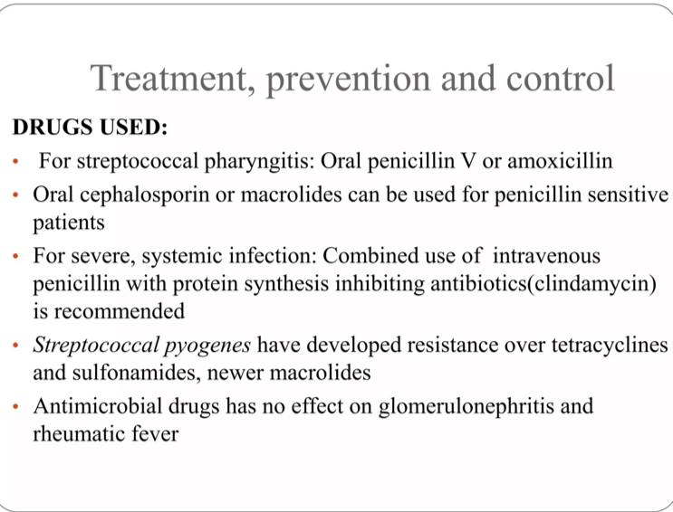

Streptococcus pneumoniae
Diseases:
Streptococcus pneumoniae causes pneumonia, bacteremia,meningitis, and infections of the upper respiratory tract such as otitis media, mastoiditis, and sinusitis. Pneumococci are the most common cause of community-acquired pneumonia, meningitis, sepsis in splenectomized individuals, otitis media, and sinusitis. They are a common cause of conjunctivitis, especially in children. Note that S. pneumoniae is also known as the pneumococcus (plural, pneumococci).
Important Properties:
Pneumococci are gram-positive lancet-shaped cocci arranged in pairs (diplococci) or short chains . (The term lancet-shaped means that the diplococci are oval with somewhat pointed ends rather than being round.) On blood agar, they produce α-hemolysis. In contrast to viridans streptococci, they are lysed by bile or deoxycholate, and their growth is inhibited by optochin Pneumococci possess polysaccharide capsules of more than 85 antigenically distinct types. With type-specific antiserum, capsules swell (quellung reaction), and this can be used to identify the type. Capsules are virulence factors (i.e., they interfere with phagocytosis and favor invasiveness). Specific antibody to the capsule opsonizes the organism, facilitates phagocytosis, and promotes resistance. Such antibody develops in humans as a result either of infection (asymptomatic or clinical) or of administration of polysaccharide vaccine. Capsular polysaccharide elicits primarily a β-cell (i.e., T-independent) response. Another important surface component of S. pneumoniae is a teichoic acid in the cell wall called C-substance (also known as C-polysaccharide). It is medically important not for itself, but because it reacts with a normal serum protein made by the liver called C-reactive protein (CRP). CRP is an “acute-phase” protein that is elevated as much as 1000- fold in acute inflammation. CRP is not an antibody (which are γ-globulins) but rather a β-globulin.

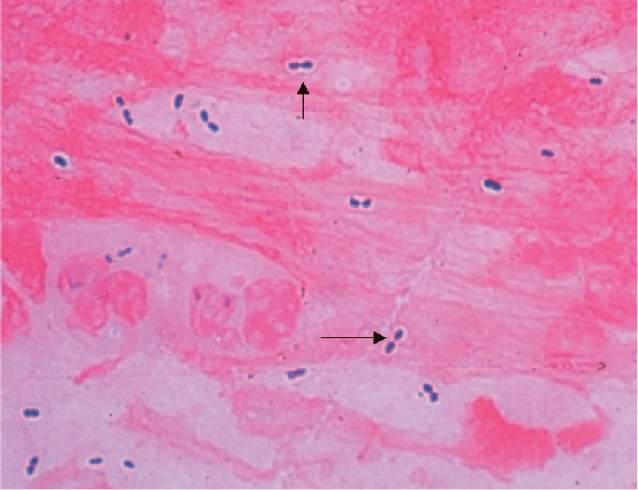

Streptococcus pneumoniae—Gram stain. Arrows point to typical gram-positive diplococci. Note that the clear area around the organism is the capsule. 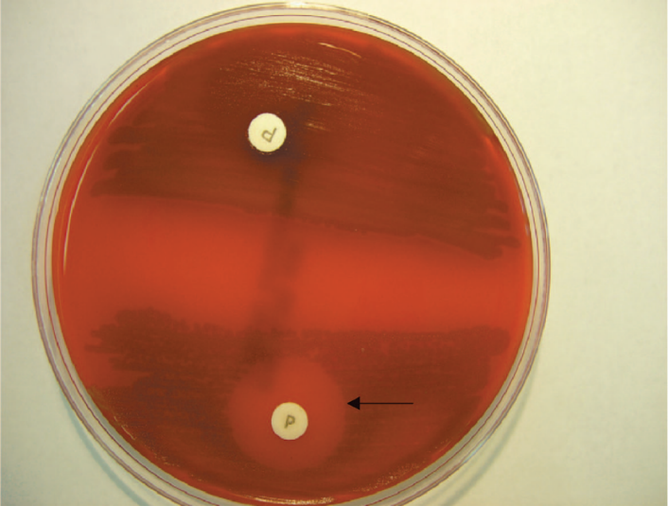

Optochin test—Arrow points to zone of inhibition of growth of Streptococcus pneumoniae caused by optochin that has diffused from the disk labeled P. In the lower half of the blood agar plate, there is α-hemolysis caused by S. pneumoniae, except in the region around the optochin disk. The arrow points to the outer limit of the zone of inhibition. Upper half of blood agar plate shows α-hemolysis caused by a viridans streptococcus, and there is no zone of inhibition around the optochin disk.

Pathogenesis.
The most important virulence factor is the capsular polysaccharide, and anticapsular antibody is protective. Lipoteichoic acid, which activates complement and induces inflammatory cytokine production, contributes to the inflammatory response and to the septic shock syndrome that occurs in some immunocompromised patients. Pneumolysin, the hemolysin that causes α-hemolysis, may also contribute to pathogenesis. Pneumococci produce IgA protease that enhances the organism’s ability to colonize the mucosa of the upper respiratory tract by cleaving IgA. Pneumococci multiply in tissues and cause inflammation. When they reach alveoli, there is outpouring of fluid and red and white blood cells, resulting in consolidation of the lung. During recovery, pneumococci are phagocytized, mononuclear cells ingest debris, and the consolidation resolves.

Laboratory diagnosis
In sputum, pneumococci are seen as lancet-shaped grampositive diplococci in Gram-stained smears. They can also be detected by using the quellung reaction with multitype antiserum. On blood agar, pneumococci form small α-hemolytic colonies. The colonies are bile-soluble (i.e., are lysed by bile), and growth is inhibited by optochin . Blood cultures are positive in 15% to 25% of pneumococcal infections. Culture of cerebrospinal fluid is usually positive in meningitis. Rapid diagnosis of pneumococcal meningitis can be made by detecting its capsular polysaccharide in spinal fluid using the latex agglutination test. A rapid test that detects urinary antigen is also available for the diagnosis of pneumococcal pneumonia and bacteremia. The urinary antigen is the C polysaccharide (also known as the C substance), not the capsular polysaccharide. Because of the increasing numbers of strains resistant to penicillin, antibiotic sensitivity tests must be done on organisms isolated from serious infections.
Treatment
Most pneumococci are susceptible to penicillins and erythromycin, although significant resistance to penicillins has emerged (see next paragraph). In severe pneumococcal infections, penicillin G is the drug of choice, whereas in mild pneumococcal infections, oral penicillin V can be used. A fluoroquinolone with good antipneumococcal activity, such as levofloxacin, can also be used. In penicillinallergic patients, erythromycin or one of its long-acting derivatives (e.g., azithromycin) can be used. About 25% of isolates exhibit lowlevel resistance to penicillin, primarily as a result of changes in penicillin-binding proteins. An increasing percentage of isolates, ranging from 15% to 35% depending on location, show high-level resistance, which is attributed to multiple changes in penicillin-binding proteins. They do not produce β-lactamase. Vancomycin is the drug of choice for the penicillin resistant pneumococci, especially for severely ill patients. Ceftriaxone or levofloxacin can be used for less severely ill patients. However, strains of pneumococci tolerant to vancomycin have emerged. Strains of pneumococci resistant to multiple drugs have also emerged

Gram-negative cocci
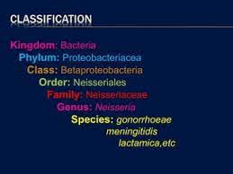

The genus Neisseria contains two important human pathogens: Neisseria meningitidis and Neisseria gonorrhoeae. Neisseria meningitidis mainly causes meningitis and meningococcemia. In the United States, it is the leading cause of death from infection in children. Neisseria gonorrhoeae causes gonorrhea , the second most common notifiable bacterial disease in the United States It also causes neonatal conjunctivitis (ophthalmia neonatorum) and pelvic inflammatory disease (PID). Note that N. meningitidis is also known as the meningococcus (plural, meningococci), and N. gonorrhoeae is also known as the gonococcus (plural, gonococci).

Important properties
Neisseriae are gram-negative cocci that resemble paired kidney beans. (1) Neisseria meningitidis (meningococcus) has a prominent polysaccharide capsule that enhances virulence by its antiphagocytic action. The capsule also is the immunogen in the vaccine that induces protective antibodies. Meningococci are divided into at least 13 serologic groups on the basis of the antigenicity of their capsular polysaccharides. Five serotypes cause most cases of meningitis and meningococcemia: A, B, C, Y, and W-135. Serotype A is the leading cause of epidemic meningitis worldwide. Serotype B accounts for most disease in the United States. This is because the group B polysaccharide is not immunogenic in humans and therefore is not part of the vaccines that contain the capsular polysaccharide of the other four groups. In 2014, a vaccine against group B meningococci containing factor H binding protein as the immunogen was approved. (2) Neisseria gonorrhoeae (gonococcus) has no polysaccharide capsule but has multiple serotypes based on the antigenicity of its pilus protein. There is marked antigenic variation in the gonococcal pili as a result of chromosomal rearrangement; more than 100 serotypes are known. Gonococci have three outer membrane proteins (proteins I, II, and III). Protein II plays a role in attachment of the organism to cells and varies antigenically as well. Neisseriae are gram-negative bacteria and contain endotoxin in their outer membrane. Note that the endotoxin of Neisseriae consist of lipooligosaccharide (LOS), in contrast to the lipopolysaccharide (LPS) found in enteric gramnegative rods. Both LPS and LOS contain lipid A, but the oligosaccharide part of LOS contains few sugars, whereas the polysaccharide part of LPS contains a long repeating sugar side chain. The growth of both organisms is inhibited by toxic trace metals and fatty acids found in certain culture media (e.g., blood agar plates). They are therefore cultured on “chocolate” agar containing blood heated to 80°C, which inactivates the inhibitors. Neisseriae are oxidase-positive (i.e., they possess the enzyme cytochrome c). This is an important laboratory diagnostic test in which colonies exposed to phenylenediamine turn purple or black as a result of oxidation of the reagent by the enzyme.
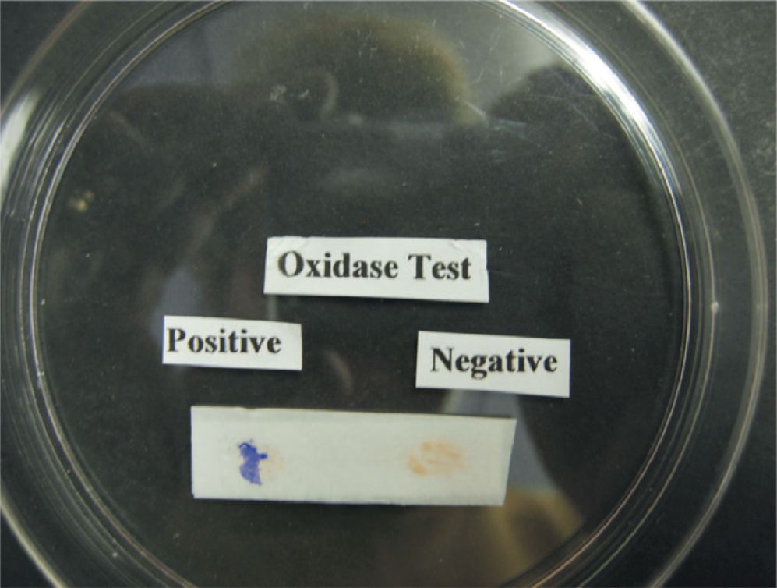
Oxidase test—A drop of the oxidase reagent was placed on the left and right side of the filter paper. Bacteria from a colony of Neisseria gonorrhoeae were rubbed on the drop on the left, and the purple color indicates a positive test (i.e., the organism is oxidase-positive). Bacteria from a colony of Escherichia coli were rubbed on the drop on the right, and the absence of a purple color indicates a negative test

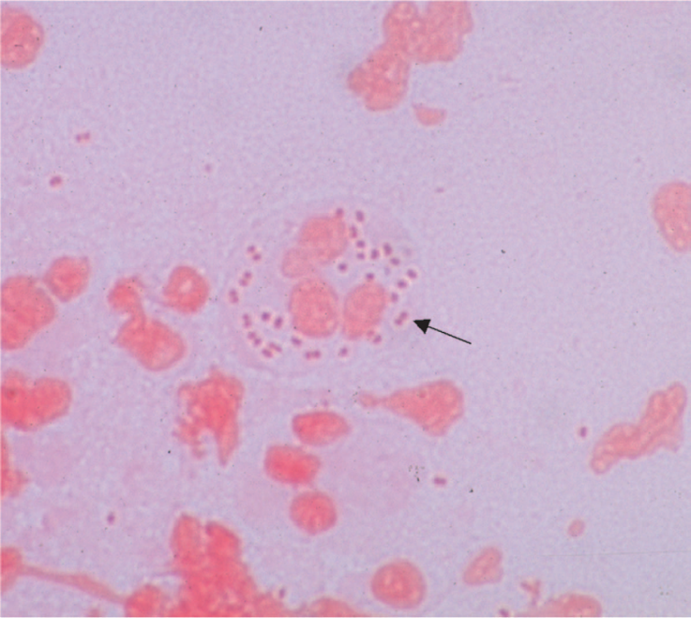
Neisseria gonorrhoeae—Gram stain. Arrow points to typical “kidney bean”–shaped gram-negative diplococci within a neutrophil.

Properties of the Polysaccharide Capsule of the Meningococcus:
(1) Enhances virulence by its antiphagocytic action
(2) Is the antigen that defines the serologic groups
(3) Is the antigen detected in the spinal fluid of patients with meningitis
(4) Is the antigen in the vaccine

Neisseria meningitidis
Pathogenesis & Epidemiology
Humans are the only natural hosts for meningococci. The organisms are transmitted by airborne droplets; they colonize the membranes of the nasopharynx and become part of the transient flora of the upper respiratory tract. Carriers are usually asymptomatic. From the nasopharynx, the organism can enter the bloodstream and spread to specific sites, such as the meninges or joints, or be disseminated throughout the body (meningococcemia). About 5% of people become chronic carriers and serve as a source of infection for others. The carriage rate can be as high as 35% in people who live in close quarters (e.g., military recruits); this explains the high frequency of outbreaks of meningitis in the armed forces prior to the use of the vaccine. The carriage rate is also high in close (family) contacts of patients. Outbreaks of meningococcal disease also have occurred in college students living in dormitories. Two organisms cause more than 80% of cases of bacterial meningitis in infants older than 2 months of age: S. pneumoniae and N. meningitidis. Of these organisms meningococci, especially those in group A, are most likely to cause epidemics of meningitis. Group B meningococci cause many cases of meningitis in developed countries because it is not present in the capsular polysaccharide vaccine. Overall, N. meningitidis ranks second to S. pneumoniae as a cause of meningitis but is the most common cause in persons between the ages of 2 and 18 years.
Meningococci have four important virulence factors: (1) A polysaccharide capsule that enables the organism to resist phagocytosis by polymorphonuclear leukocytes (PMNs). The capsule is the immunogen in several commonly used vaccines against meningococci. (2) Endotoxin, which causes fever, shock, and other pathophysiologic changes (in purified form, endotoxin can reproduce many of the clinical manifestations of meningococcemia). (3) An immunoglobulin A (IgA) protease that helps the bacteria attach to the membranes of the upper respiratory tract by cleaving secretory IgA. (4) Factor H binding protein (FHBP) on meningococci binds Factor H, an inhibitor of complement factor C3b. The presence of Factor H on the surface of meningococci reduces the opsonizing activity of C3b and reduces the amount of membrane attack complex produced. FHBP is the immunogen in the vaccine against group B meningococci.
Clinical findings
The two most important manifestations of disease are meningococcemia and meningitis. The most severe form of meningococcemia is the life-threatening Waterhouse–Friderichsen syndrome, which is characterized by high fever, shock, widespread purpura, disseminated intravascular coagulation, thrombocytopenia, and adrenal insufficiency. Bacteremia can result in the seeding of many organs, especially the meninges. The symptoms of meningococcal meningitis are those of typical bacterial meningitis, namely, fever, headache, stiff neck, and an increased level of PMNs in spinal fluid.
Laboratory diaqnosis
The principal laboratory procedures are smear and culture of blood and spinal fluid samples. A presumptive diagnosis of meningococcal meningitis can be made if gram-negative cocci are seen in a smear of spinal fluid .The organism grows best on chocolate agar incubated at 37°C in a 5% CO2 atmosphere. A presumptive diagnosis of Neisseria can be made if oxidase-positive colonies of gramnegative diplococci are found. The differentiation between N. meningitidis and N. gonorrhoeae is made on the basis of sugar fermentation: meningococci ferment maltose, whereas gonococci do not (both organisms ferment glucose). Immunofluorescence can also be used to identify these species. Tests for serum antibodies are not useful for clinical diagnosis. However, a procedure that can assist in the rapid diagnosis of meningococcal meningitis is the latex agglutination test, which detects capsular polysaccharide in the spinal fluid.
Treatment
Penicillin G is the treatment of choice for meningococcal infections. A third-generation cephalosporin such as ceftriaxone can also be used. Strains resistant to penicillin have rarely emerged, but sulfonamide resistance is common. In 2007–2008, strains of N. meningitidis resistant to ciprofloxacin emerged.

Neisseria gonorrhoeae
Pathogenesis & Epidemiology
Gonococci, like meningococci, cause disease only in humans. The organism is usually transmitted sexually; newborns can be infected during birth. Because gonococcus is quite sensitive to dehydration and cool conditions, sexual transmission favors its survival. Gonorrhea is usually symptomatic in men but often asymptomatic in women. Genital tract infections are the most common source of the organism, but anorectal and pharyngeal infections are important sources as well. Pili constitute one of the most important virulence factors, because they mediate attachment to mucosal cell surfaces and are antiphagocytic. Piliated gonococci are usually virulent, whereas nonpiliated strains are avirulent. Two virulence factors in the cell wall are endotoxin (lipooligosaccharide, LOS) and the outer membrane proteins. The organism’s IgA protease can hydrolyze secretory IgA, which could otherwise block attachment to the mucosa. Gonococci have no capsules. The main host defenses against gonococci are antibodies (IgA and IgG), complement, and neutrophils. Antibodymediated opsonization and killing within phagocytes occur, but repeated gonococcal infections are common, primarily as a result of antigenic changes of pili and the outer membrane proteins. Gonococci infect primarily the mucosal surfaces (e.g., the urethra and vagina), but dissemination occurs. Certain strains of gonococci cause disseminated infections more frequently than others. The most important feature of these strains is their resistance to being killed by antibodies and complement. The mechanism of this “serum resistance” is uncertain, but the presence of a porin protein (porin A) in the cell wall, which inactivates the C3b component of complement, appears to play an important role.
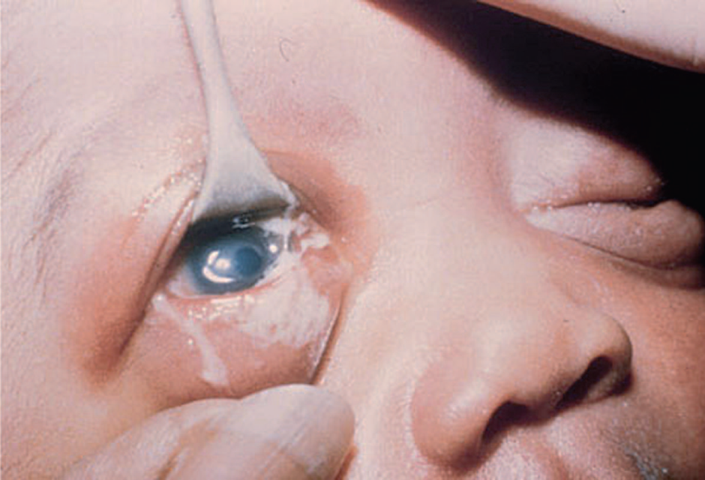
Neonatal conjunctivitis (ophthalmia neonatorum) caused by Neisseria gonorrhoeae. Note purulent exudate, especially on lower right eyelid. The other common cause of neonatal conjunctivitis is Chlamydia trachomatis.

Laboratory Diagnosis
The diagnosis of urogenital infections depends on Gram staining and culture of the discharge However, nucleic acid amplification tests are widely used as screening tests (see later). In men, the finding of gram-negative diplococci within PMNs in a urethral discharge specimen is sufficient for diagnosis. In women, the use of the Gram stain alone can be difficult to interpret; therefore, cultures should be done. Gram stains on cervical specimens can be falsely positive because of the presence of gram-negative diplococci in the normal flora and can be falsely negative because of the inability to see small numbers of gonococci when using the oil immersion lens. Cultures must also be used in diagnosing suspected pharyngitis or anorectal infections.
Treatment
Ceftriaxone is the treatment of choice in uncomplicated gonococcal infections. Azithromycin or ciprofloxacin should be used if the patient is allergic to penicillins or cephalosporins. Because mixed infections with C. trachomatis are common, azithromycin or doxycycline should be prescribed also. A follow-up culture should be performed 1 week after completion of treatment to determine whether gonococci are still present. Treatment of complicated gonococcal infections, such as PID, typically requires hospitalization. Treatment regimens are complex and beyond the scope of this book. Prior to the mid-1950s, all gonococci were highly sensitive to penicillin. Subsequently, isolates emerged with lowlevel resistance to penicillin and to other antibiotics such as tetracycline and chloramphenicol. This type of resistance is encoded by the bacterial chromosome and is due to reduced uptake of the drug or to altered binding sites rather than to enzymatic degradation of the drug .Then, in 1976, penicillinase-producing (PPNG) strains that exhibited high-level resistance were isolated from patients. Penicillinase is plasmid-encoded. PPNG strains are now common in many areas of the world, including several urban areas in the United States, where approximately 10% of isolates are resistant. Isolates resistant to fluoroquinolones, such as ciprofloxacin, have become a significant problem, and fluoroquinolones are not recommended as treatment.

Opportunistic bacteria
Pseudomonas
Diseases
Pseudomonas aeruginosa causes infections (e.g., sepsis. pneumonia, and urinary tract infections) primarily in patients with lowered host defenses. It also causes chronic lower respiratory tract infections in patients with cystic fibrosis, wound infections (cellulitis) in burn patients), and malignant otitis externa in diabetic patients. It is the most common cause o ventilator-associated pneumonia.
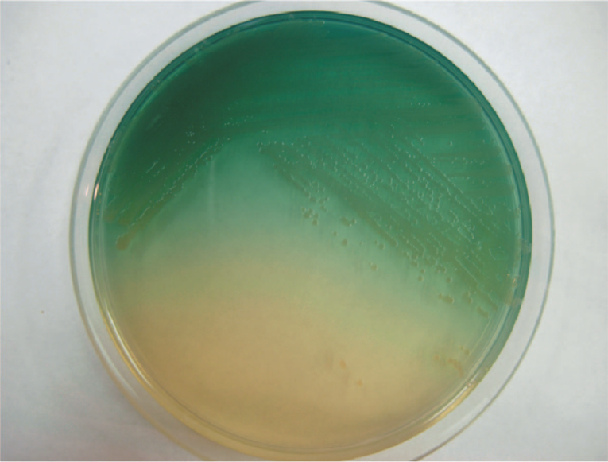
Pseudomonas aeruginosa—blue-green pigment. Blue-green pigment (pyocyanin) produced by P. aeruginosa diffuses into the agar.
Important Properties
Pseudomonads are gram-negative rods that resemble the members of the Enterobacteriaceae but differ in that they are strict aerobes (i.e., they derive their energy only by oxidation of sugars rather than by fermentation). Because thev do not ferment glucose, they are called nontermenters, in contrast to the members of the Enterobacteriaceae, which do ferment glucose. Oxidation involves electron transport by cvtochrome c (i.e., they are oxidase-positive). Pseudomonads are able to grow in water containing only traces of nutrients (e.g, tap water), and this favors their persistence in the hospital environment. . Pseudomonas aeruginosa produces two pigments useful in clinical and laboratory diagnosis: (1) pyocyanin, which can color the pus in a wound blue, and (2) pyoverdin (fluorescein), a yellow-green pigment that fluoresces under ultraviolet light, a property that can be used in the early detection of skin infection in burn patients. In the labora-tory, these pigments diffuse into the agar, imparting a blue-green color that is useful in identification. Pseudomo-as geruginosa is the only species of Pseudomonas that synthesizes pyocyanin . Strains of P. aeruginosa isolated from cystic fibrosis patients have a prominent slime layer (glycocalyx), which gives their colonies a very mucoid appearance. The slime layer mediates adherence of the organism to mucous mem- branes of the respiratory tract and prevents antibody from binding to the organism

Pathogenesis & Epidemiology
Pseudomonas aeruginosa is found chiefly in soil and water, although approximately 10% of people carry it in the norma flora of the colon. It is found on the skin in moist areas and can colonize the upper respiratory tract of hospitalized patients. Its ability to grow in simple aqueous solu-tions has resulted in contamination of respiratory therapy and anesthesia equipment, intravenous fluids, and even
distillled water. Pseudomonas aeruginosa is primarily an opportunistic pathogen that causes infections in hospitalized patients (e.g., those with extensive burns), in whom the skin host detenses are destroyed; in those with chronic respiratory disease (e.g., cystic fibrosis), in whom the normal clearance mechanisms are impaired; in those who are immunosup-pressed; in those with neutrophil counts of less than 500/pI; and in those with indwelling catheters. It causes 10% to 20% of hospital-acquired infections and, in many hospitals, is the most common cause of gram-negative nosocomial pneumonia, especially ventilator-associated pneumonia.
Pathogenesis is based on multiple virulence factors: endotoxin. exotoxins. and enzvmes. Its endotoxin. like that of other gram-negative bacteria, causes the symptoms of sepsis and septic shock. The best known of the exotoxins is exotoxin A, which causes tissue necrosis. It also produces enzymes, such as elastase and proteases that are histotoxic and facilitate invasion of the organism into the bloodstream. Pyocyanin damages the cilia and mucosal cells of the respiratory tract.
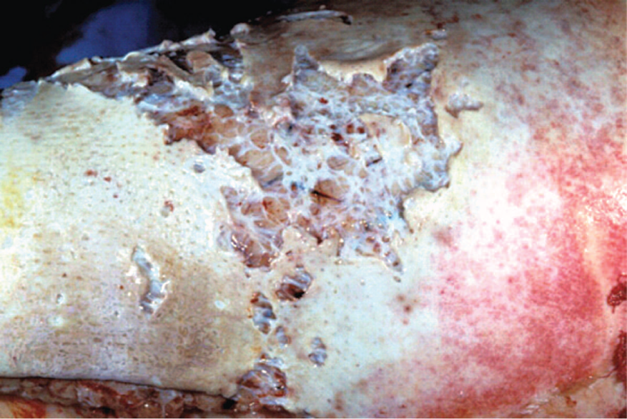
Cellulitis caused by Pseudomonas aeruginosa. Note the blue-green color of the pus in the burn wound infection.
Clinical Findings
Pseudomonas aeruginosa can cause infections virtually anywhere in the body, but urinary tract infections, pneumonia (especially in cystic fibrosis patients), and wound infections (especially burns) predomi-nate. It is an important cause of hospital-acquired pneumonia, especially in those undergoing
mechanical ventilation. From these sites, the organism can enter the blood, causing sepsis. The bacteria can spread to the skin, where they cause black, necrotic lesions called ecthyma gangrenosum. Patients with P. aeruginosa sepsis have a mortality rate of greater than 50%. It is an important cause of endo. carditis in intravenous drug users. Severe external otitisand other skin lesions (e.g., folliculitis) occur in users of swimming pools and hot tubs (hot tub folliculitis) in which the chlorination is inadequate. Pseudomonas aeruginosa is the most common cause of osteomyelitisof the foot in those who sustain puncture wounds through the soles of gym shoes. Corneal infections caused by P. aeruginosa are seen
in contact lens users.

Laboratory Diagnosis
Pseudomonas aeruginosa grows as non-lactose-fermenting (colorless) colonies on MacConkey's or EMB agar. It is oxidase-positive. A typical metallic sheen of the growth on TSI agar, coupled with the blue-green pigment on ordinary nutrient agar, and a fruity aroma are sufficient to make a presumptive diagnosis. The diagnosis is contirmed b biochemica reactions. dentitication tol epidemiologic purposes is done by bacteriophage or pyo-cin typing.

Treatment
Because P. aeruginosa is resistant to many antibiotics, treatment must be tailored to the sensitivity of each iso late and monitored frequently; resistant strains can emerge during therapy. The treatment of choice is ar antipseudomonal penicillin (e.g., piperacillin/tazobac-tam or ticarcillin/clavulanate) plus an aminoglycoside (e.g., gentamicin or amikacin). Ceftazidime is also effec-tive.For infections caused by highly resistant strains, colistin (polymyxin E is useful. The drug of choice for urinary tract infections is ciprofloxacin. The drug of choice for infections caused by B. cepacia and S. malto philia is trimethoprim-sulfamethoxazole.

Proteus
Diseases
These organisms primarily cause urinary tract infections, both community- and hospital-acquired.

Important Properties
These gram-negative rods are distinguished from other members of the Enterobacteriacee by their ability to produce the enzyme phenylalanine deaminase. In addition, they produce the enzyme urease, which cleaves urea to form NH; and CO2. Certain species are very motile and produce a striking swarming effect on blood agar, characterized by expanding rings (waves) of organisms over the surface of the agar (Figure 18-4).
The cell wall O antigens of certain strains of Proteus, such as OX-2, OX-19, and OX-K, cross-react with antigens of several species of rickettsiae. These Proteus antigens can be used in laboratory tests to detect the presence of antibodies against certain rickettsiae in patients' serum. This test, called the Weil-Felix reaction after its originators, is being used less frequently as more specific procedures are developed. In the past, there were four medically important species of Proteus. However, molecular studies of DNA relatedness showed that two of the four were significantly different.These species have been renamed: Proteus morganit is now Morganella morganii, and Proteus rettgeri is now Providen-cia rettgeri. In the clinical laboratory, these organisms are distinguished from Proteus vulgaris and Proteus mirabilis on the basis of several biochemical tests.
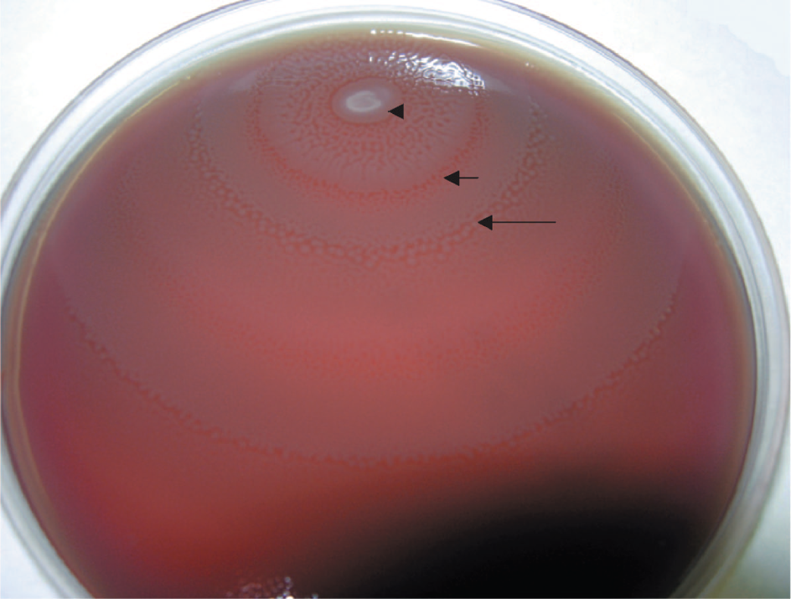
Proteus species—swarming motility on blood agar. Arrowhead points to the site where Proteus bacteria were
placed on the blood agar. Short arrow points to the edge of the first ring of swarming motility. Long arrow points to the edge of the second ring of swarming motility.
Pathogenesis & Epidemiology
The organisms are present in the human colon as well as in soil and water. Their tendency to cause urinary tract infections is probably due to their presence in the colon and to colonization of the urethra, especially in women. The vigorous motility of Proteus organisms may contribute to their ability to invade the urinary tract. Production of the enzyme urease is an important feature of the pathogenesis of urinary tract infections by this group.
Urease hydrolyzes the urea in urine to form ammonia, which raises the pH, producing an alkaline urine. This encourages the formation of stones (calculi) called "struvite" composed of magnesium ammonium phosphate. Struvite stones often manifest, as staghorn calculi in the renal pelvis. They obstruct urine flow, damage urinary epithelium, and serve as a nidus for recurrent infection by trapping bacteria within the stone. Because alkaline urine also favors growth of the organisms and more extensive renal damage, treatment involves keeping the urine at a low pH.

Clinical Findings
The signs and symptoms of urinary tract infections caused by these organisms cannot be distinguished from those caused by E. coli or other members of the Enterobacteria-ceae. Proteus species can also cause pneumonia, wound infections, and septicemia. Proteus mirabilis is the species of Proteus that causes most community- and hospital-acquired infections, but P. rettgeri is emerging as an important agent of nosocomial infections.

Laboratory Diagnosis
These organisms usually are highly motile and produce a swarming" overgrowth on blood agar, which can frustrate efforts to recover pure cultures of other organisms. Growth on blood agar containing phenylethyl alcohol inhibits swarming, thus allowing isolated colonies of Proteus and other organisms to be obtained. They produce non-lactose-fermenting (colorless) colonies on MacConkey's or EMB agar. Proteus vulgaris and P. mirabilis produce H2S, which blackens the butt of TSI agar, whereas neither M. morganii nor P. rettgeri does. Proteus mirabilis is indole-negative, whereas the other three species are indole-positive-a distinction that can be used clinically to guide the choice of antibiotics. These four medically important species are urease-positive. Identification of these organisms in the clinical laboratory is based on a variety of biochemical reactions.
Treatment
Most strains are sensitive to aminoglycosides and trimethoprim-sulfamethoxazole, but because individual isolates can vary, antibiotic sensitivity tests should be per-formed. Proteus mirabilis is the species most frequently sen sitive to ampicillin. The indole-positive species (P. vulgaris,
M. morgani, and P. rettgeri) are more resistant to antibiotics than is P. mirabilis, which is indole-negative. The treatment of choice for the indole-positive species is a cephalosporin (e.g., cefotaxime). Proteus retigeri is frequently resistant to multiple antibiotics.

Klebsiella
Diseases
These organisms are usually opportunistic pathogens that
cause nosocomial intections, especially pneumonia and urinary tract infections. Klebsiella pneumonia is an important respiratory tract pathogen outside hospitals as well.
Important Properties
Klebsiella pneumonia, Enterobacter cloacae, and Serratia marcescens are the species most often involved in human infections. They are frequently found in the large intestine but are also present in soil and water. These organisms have very similar properties and are usually distinguished on the basis of several biochemical reactions and motility.
Klebsiella pneumonia has a very large polysaccharide capsule, which gives its colonies a striking mucoid appear-ance. serratia marcescens produces red-pigmented colonies.
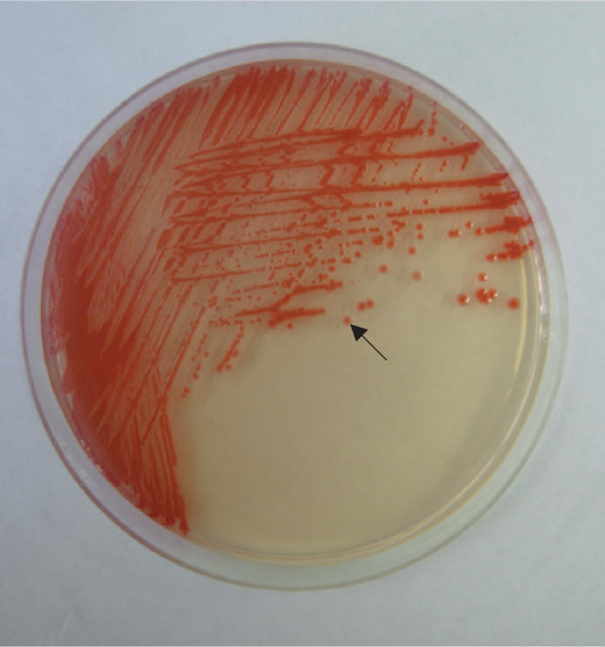.
Serratia marcescens—red-pigmented colonies. Arrow points to a red-pigmented colony of S. marcescens

Pathogenesis & Epidemiology
Of the three organisms, K. pneumoniae is most likely to be a primary, nonopportunistic pathogen; this property is related to its antiphagocytic capsule. Although this organism is a primary pathogen, patients with K. pneumoniae infections frequently have predisposing conditions such as advanced age, chronic respiratory disease, diabetes, or alco-holism. The organism is carried in the respiratory tract of about 10% of healthy people, who are prone to pneumonia if host defenses are lowered.

Clinical Findings
Urinary tract infections and pneumonia are the usual clinical entities associated with these three bacteria, but bacteremia and secondary spread to other areas such as the meninges and liver occur. It is difficult to distinguish infections caused by these organisms on clinical grounds, with
the exception of pneumonia caused by Klebsiella, which produces a thick, mucoid, bloody sputum ("currant-jelly" sputum) and can progress to necrosis and abscess formation.
There are two other species of Klebsiella that cause unusual human infections rarely seen in the United States.
Klebsiella ozaenae is associated with atrophic rhinitis, and Klebsiella rhinoscleromatis causes a destructive granuloma of the nose and pharynx.

Laboratory Diagnosis
Organisms of this group produce lactose-fermenting (col-ored) colonies on differential agar such as MacConkey's or EMB, although Serratia, which is a late lactose fermenter, can produce a negative reaction. These organisms are dif ferentiated by the use of biochemical tests.
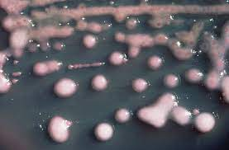
Treatment
Because the antibiotic resistance of these organisms can vary greatly, the choice of drug depends on the results of sensitivity testing. Isolates from hospital-acquired infections are frequently resistant to multiple antibiotics. Carbapenem-resistant strains are an important cause of hospital-acquired infections and are resistant to almost all known antibiotics. An aminoglycoside (e.g., gentamicin) and a cephalosporin (e.g., cefotaxime) are used empirically until the results of testing are known. In severe Enterobacter infections, a combination of imipenem and gentamicin is often used.

